E-COMMERCE SALES & BUSINESS ANALYTICS
Business Analytics Case Study

Submitted By: Siddhant Thorat
Internship: Davine Technologies
Dataset: E-commerce Customer, Orders, Order Items and Products
Tools: MySQL / SQL and Power BI
Data → Cleaning → SQL Analysis → Visualization → Insights → Recommendations

1. Project Overview
This project is an e-commerce analytics case study created to understand business performance across sales, customers, products, orders and profitability. MySQL was used for data validation, cleaning, joining and analysis, while Power BI was used to create an interactive dashboard.

2. Business Problem
Management wants a clear view of e-commerce performance to understand sales, customers, products, profitability and overall trends.
- Measure revenue, orders, quantity sold and profit.
- Understand monthly sales trends.
- Identify high-performing categories and products.
- Compare revenue across states.
- Understand customer revenue contribution.
- Compare acquisition channels and payment methods.
- Review order status and discount activity.

3. Dataset
The project uses four related CSV datasets.
Dataset | Details
customers.csv | 3,600 rows; 4 columns
orders.csv | 9,245 rows; 7 columns
order_items.csv | 15,608 rows; 5 columns
products.csv | 90 rows; 5 columns
Relationships:
- customers.customer_id → orders.customer_id
- orders.order_id → order_items.order_id
- products.product_id → order_items.product_id

4. Data Cleaning and Preparation
- 38 duplicate order records were identified and removed in the cleaned order view.
- Blank discount codes were handled as 'No Discount' for analysis.
- Product categories were standardized using TRIM and UPPER.
- 199 missing unit-price values were handled using the corresponding product list price.
- Cleaned SQL views were created for orders, order items and products.
- A combined sales_detail view was created by joining customers, orders, order items and products.
- Relationship and data-quality checks were performed.

5. SQL Analysis Methodology
SQL was the main analysis tool for this project.
- JOIN for combining the four datasets.
- GROUP BY for category, state, customer, product and acquisition analysis.
- SUM, COUNT and AVG for business KPIs.
- CASE and COALESCE for data preparation.
- DATE_FORMAT for monthly analysis.
- Top-N queries for products and customers.
Main calculations:
- Gross Sales = Quantity × Unit Price
- Net Sales = Gross Sales − Discount Amount
- Profit = Net Sales − (Quantity × Unit Cost)
- Average Order Value = Total Revenue ÷ Total Orders
- Profit Margin = Total Profit ÷ Total Revenue

6. Key Performance Indicators
KPI | Result
Total Revenue | $1.86M
Total Orders | 8K
Total Quantity | 18K
Total Profit | $914.16K
Profit Margin | 49.20%
Total Customers | 2K
Average Order Value | $221.28
Revenue per Customer | $908.17
Total Discount | $44.57K

7. Power BI Dashboard

Page 1 – E-Commerce Sales Overview
- Total Revenue, Total Orders, Total Quantity, Total Profit and Profit Margin.
- Monthly Revenue.
- Revenue by Category.
- Revenue by State.
- Top 10 Products by Revenue.
- Year/Month, Category and State slicers.

Page 2 – Customer & Business Insights
- Total Customers, Average Order Value, Revenue per Customer and Total Discount.
- Revenue by Acquisition Channel.
- Orders by Payment Method.
- Order Status Distribution.
- Top 10 Customers by Revenue.
- Profit by Category.
- Payment Method, Category and Acquisition Channel slicers.

Dashboard Screenshot – Sales Overview
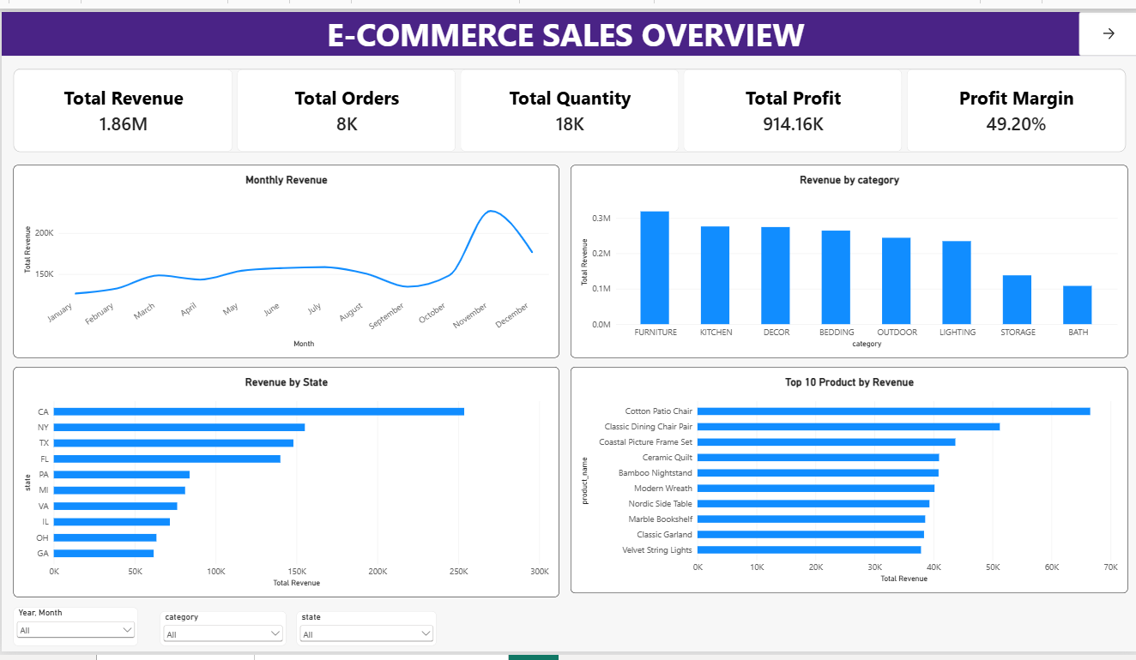

Dashboard Screenshot – Customer & Business Insights
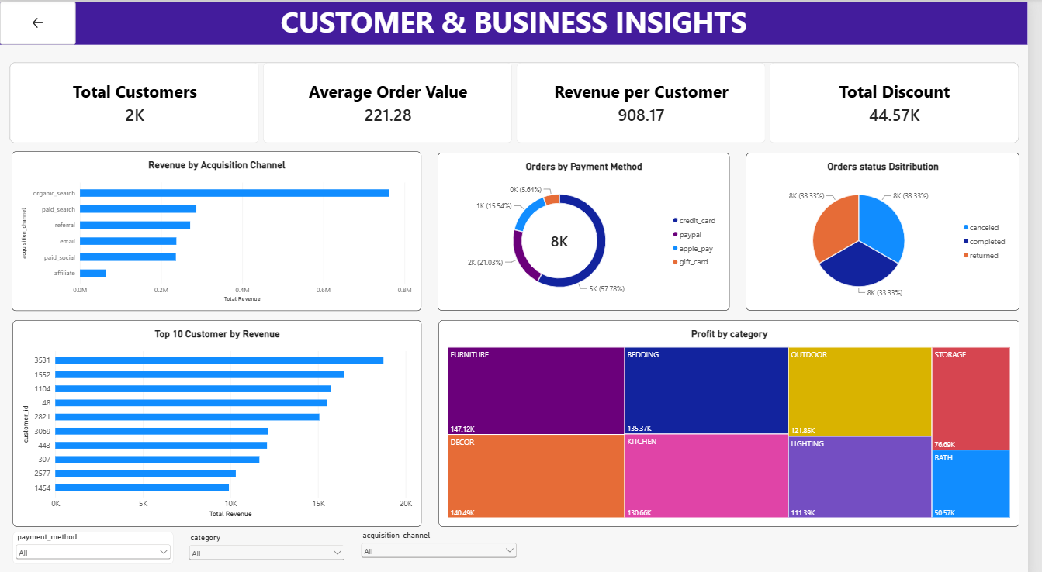

8. Key Business Insights
- The business generated approximately $1.86M in revenue with approximately $914.16K in profit, resulting in a 49.20% profit margin.
- November recorded the highest monthly revenue at approximately $230K, showing a strong late-year sales peak.
- Furniture was the highest-revenue category at approximately $320K, followed by Kitchen and Decor.
- California generated the highest state-level revenue at approximately $250K, followed by New York and Texas.
- Organic Search was the highest-revenue acquisition channel, generating approximately $760K.
- Cotton Patio Chair was the top product by revenue, generating approximately $68K.
- Customer 3531 was the highest-revenue customer, contributing approximately $18.5K.
- Furniture also produced the highest displayed category profit, at approximately $147.12K.

9. Data-Driven Recommendations
1. Strengthen high-performing acquisition channels
Organic Search generates the highest revenue among the displayed acquisition channels. The business can continue improving its organic search presence and monitor its contribution over time.
2. Prepare for the November sales peak
November shows the highest monthly revenue. Inventory, marketing and operational planning should be prepared ahead of this period to support higher demand.
3. Prioritize high-performing categories and products
Furniture has the highest revenue and category profit, while Cotton Patio Chair is the leading product by revenue. These high-performing products can receive focused inventory and promotional planning.

10. Conclusion
This project demonstrates an end-to-end e-commerce analytics workflow using SQL and Power BI. The four source datasets were validated, cleaned and combined in MySQL before calculating business KPIs and performance metrics. Power BI was then used to present the results through an interactive two-page dashboard. The analysis provides a view of revenue, profitability, product performance, customer contribution, acquisition channels and geographic performance.

11. Tools Used
- MySQL / MySQL Workbench
- SQL
- Power BI Desktop
- Microsoft Word

12. Project Deliverables
- Cleaned and prepared e-commerce data
- SQL analysis file
- Power BI dashboard (.pbix)
- Dashboard screenshots
- Business report
- GitHub repository and README documentation

